

100 DAYS RTL PART-1

Day 31: 8:1 mux-CONDITIONAL OPERATORS

Day 32: logic gates using 2:1mux

Day 33: barrel shifter

Day 34: blocking code

Day 35: non-blocking code

Day 36: datatypes

Day 37: vector assignments (greater)

Day 38: vector assignments (lesser)

Day 39: vector assignments (equal)

Day 40: vector assignments (signed)

Day 31: 8:1 mux-Conditional Operators

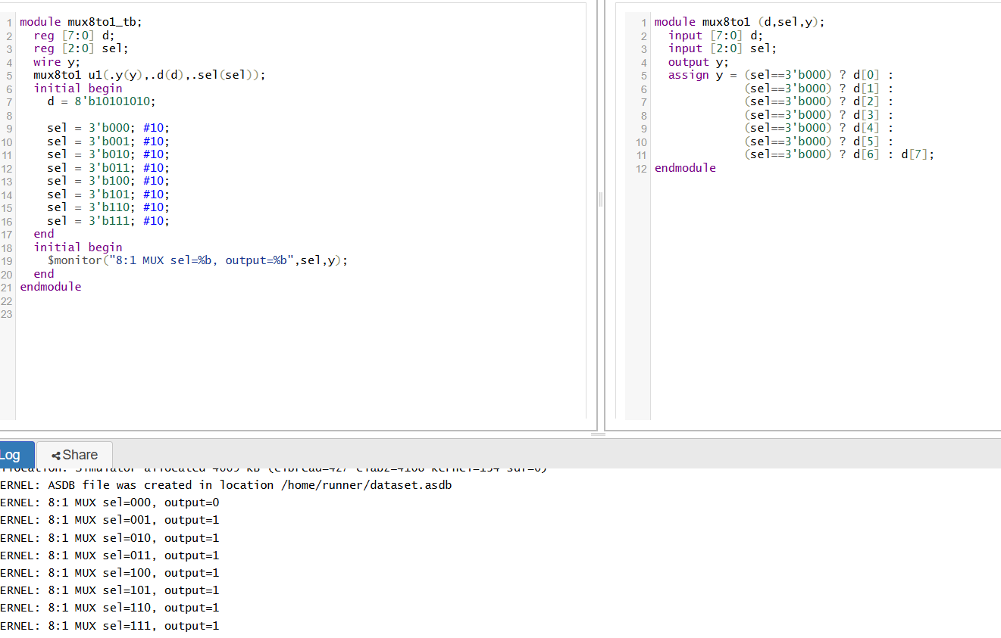

🧠 Core Concept of Multiplexing
- An 8:1 mux has 8 data inputs, 3 select lines (to choose one of the 8), and 1 output.
- The select lines (call them s2, s1, s0) are like a 3-bit pointer. The selected input is the one whose index matches that pointer.
- Its internal behavior can be seen in its truth table:
s2 s1 s0 → out
0 0 0 → d0
0 0 1 → d1
0 1 0 → d2
...
1 1 1 → d7
Using Nested Conditional Operators
- The ternary operator is condition ? true_value : false_value.
- Applied to a 2:1 mux, it selects between two inputs based on one condition.
- To handle 8 inputs, you nest these operators:
- Test s2 first:
  - If s2 = 0, you choose among d0–d3 using s1,s0.
  - If s2 = 1, you choose among d4–d7.
- Each of those mid-tier choices themselves is decided by another nested ?: based on s1, cascading down to s0.
This effectively creates a hierarchy of 2:1 muxes nested within each other.

You can build an 8:1 mux by nesting conditional operators:
- Top-level selects between groups with s2.
- Within each group, s1 and s0 index the exact input.
This is a combinational, continuous assignment—no procedural blocks needed.
Benefits include concise syntax, good synthesis results, and direct X-state behavior.
Drawbacks lie mainly in readability and future maintainability.

Day 32: Logic Gates using 2:1 mux

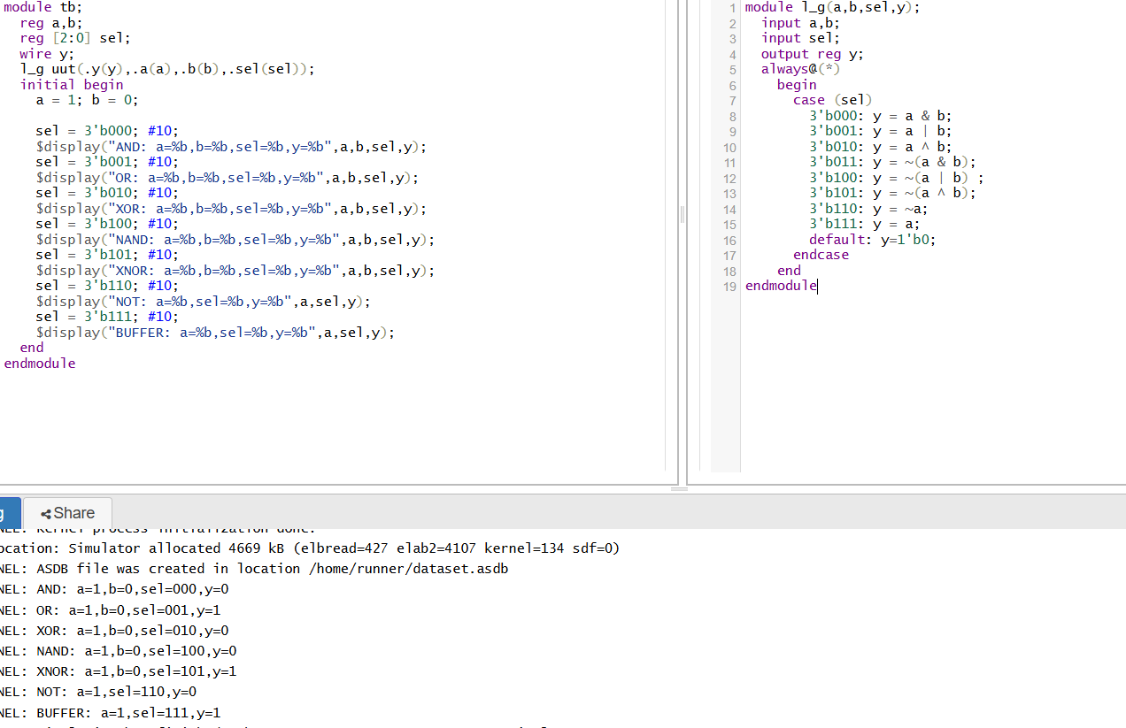

🎯 1. The 2:1 MUX as a Universal Logic Unit
A 2:1 MUX selects one of two data inputs (D0, D1) based on a select line (S). Its fundamental Boolean expression is:
ini
CopyEdit
Y = ¬S ⋅ D0 + S ⋅ D1
This means when S=0, output follows D0; when S=1, it follows D1
Because of this flexibility, a 2:1 MUX can behave like any 2-input logic gate simply by hard-wiring one or both data inputs to logic 0, 1, or to inputs/negations of the variables .

⚙️ 2. Implementing Common Gates
Here’s how to configure the MUX for various gates using inputs A, B, and working off S = A (commonly):
Gate | MUX Inputs (S=A) | Behavior
NOT A | D0 = 1, D1 = 0 | Y = ¬A
AAND B | D0 = 0, D1 = B | Y = A•B
A OR B | D0 = B, D1 = 1 | Y = A + B
ANAND B | Requires two MUXes: first to generate ¬(A AND B) via configuration, then invert
A NOR B | Same two-stage approach: use to produce ¬(A OR B)
A XOR B | Two MUXes: first for B⊕¬A, then another with A to complete XOR
A XNOR B | Similar to XOR, with inverted final output
Example: AND gate via a single MUX
- Connect S = A
- D0 = 0, D1 = B
- Output: when A=0, Y=0; when A=1, Y=B ⇒ that's A AND B Example: OR gate
- Connect S = A
- D0 = B, D1 = 1
- Y becomes B when A=0, and 1 when A=1, thus A + B \
🔁 3. Multi-Stage Constructions
More complex gates like NAND, NOR, XOR, and XNOR can be built by chaining 2:1 MUXes:

- Use a first MUX to form an intermediate function (e.g., AND).
- Feed that into a second MUX configured to invert or combine that result appropriately

🧮 4. Why It Matters
- MUX-based implementations offer design flexibility, allowing a single IC or configurable block to act as multiple gates.

- They form the foundation of FPGA lookup tables (LUTs) where multiplexing is used to synthesize arbitrary logic functions.

Day 33: Barrel Shifter

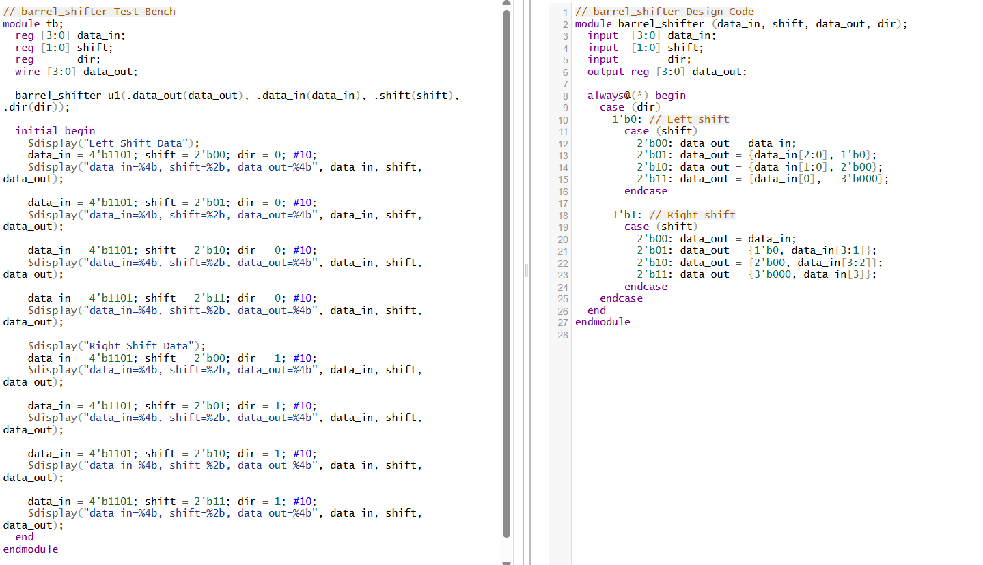
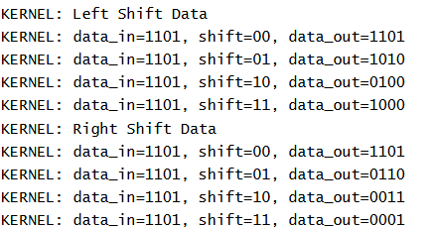

barrel shifter in Verilog is a purely combinational circuit that can shift or rotate an n-bit data word by any number of bit positions in one clock cycle, as opposed to a sequential register shifter which takes n cycles to shift n bits

⚙️ How It Works Under the Hood
- Multiplexer Tree Structure
  - Built as a cascade of shift stages: each stage handles shifting by 2ᵏ bits using an array of 2-to-1 multiplexers.
  - Example for an 8-bit barrel shifter:
    - Stage 1 (controlled by S[2]): shift by 4 bits or pass-through
    - Stage 2 (S[1]): shift by 2 bits
    - Stage 3 (S[0]): shift by 1 bit
  - Complex shifters (e.g., 64-bit) follow the same log₂(n) stage pattern.
- Rotations vs. Logical Shifts
  - You can implement rotate by using wrap-around connections in the mux tree.
  - For logical shifts, feed zeros into the vacated positions.
  - A right shift by x and a left shift by n−x are functionally the same in rotation
- Performance Trade-offs
  - Latency: O(log n) due to the stages of muxes
  - Area: O(n log n) multiplexers for an n-bit word
  - Very fast (single-cycle shift) at the expense of higher gate count and routing complexity relative to sequential shifters

Day 34: Blocking code

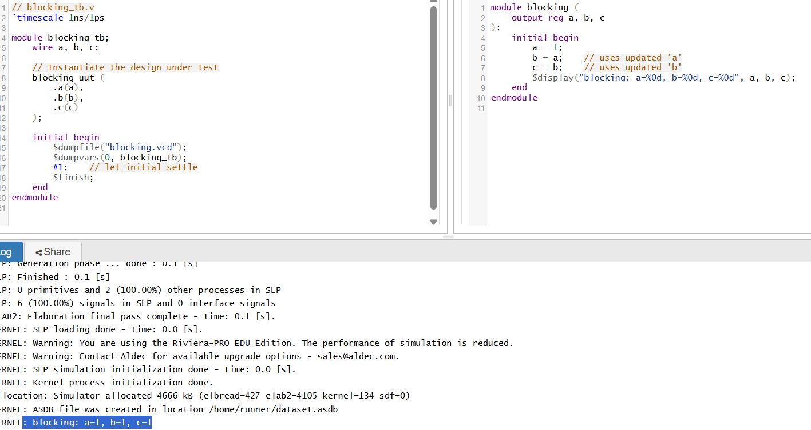
👇 Blocking Assignment (=)
- Executes sequentially, mimicking typical software statements.
- RHS is evaluated and assigned to LHS immediately, before moving to the next statement.
- Use blocking for combinational logic and in initial blocks for setup or testbenches.
🔄 Blocking Part (a = 1; b = a; c = b;)
- a = 1; immediately sets a = 1.
- b = a; sees the updated a, so b = 1.
- c = b; likewise sees b = 1, so c = 1.
- Output: blocking: a=1, b=1, c=1

⚙️ Why It Matters
- Blocking assignments are immediate and predictable; essential for combinational logic and testbench setup.
- Non-blocking assignments enable proper modeling of hardware registers and flip-flops, preventing unintended data propagation or race conditions.
📋 Simulation Flow Summary
- Blocking section executes and completes all updates before the first $display.
- Delay of #5.
Day 35: Non-Blocking code

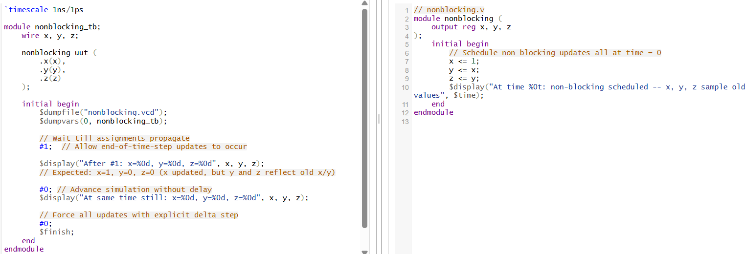
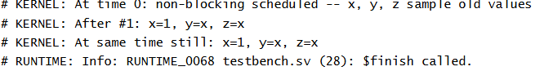

• Non-blocking assignment (<=)
- Evaluates RHS of all such statements in a block at the same time, then updates all LHS simultaneously at the end of the time-step.
- Enables modeling of parallel updates in sequential logic (e.g., registers on a clock edge).
- Prevents “ripple” updates within the same block.
• Non-blocking part (x <= 1; y <= x; z <= y;)
At time 5:
- RHS values are sampled immediately: 1, old x, old y.
- Assignments are scheduled, not executed yet.
- Thus the $display shows old values (possibly 0 or x).
⚠️ Common Pitfalls & Best Practices
- Never mix = and <= in the same always block unless you're fully aware of interleaved behavior — mixing causes mismatches between simulation and actual hardware.
- Use <= in clocked blocks (e.g., always @(posedge clk)).
- Use = in combinational blocks (e.g., always @*) and in initial code for testbenches and initialization.
- Testbench flows: blocking helps set up known states, while non-blocking models behavior based on timing or clocks.

✅ Summary
- = (blocking) assigns immediately and sequentially — great for combinational logic.
- <= (non-blocking) defers assignment — essential for register behavior in the same clock cycle.
- Use them correctly to model hardware accurately and avoid race conditions or simulation mismatches.

Day 36: Datatypes

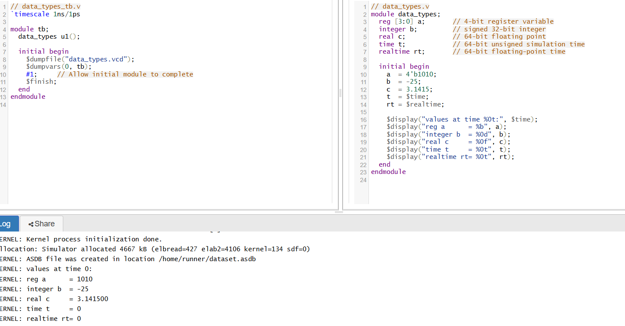

🧠 Theory: Understanding the Data Types
1. reg [3:0] a
- Holds a 4-bit value, ideal for flip-flops or combinational logic storage.
- Can represent unknown (X) or high-impedance (Z) states.
2. integer b
- A 32-bit signed variable, suited for loops, counters, or general math.
3. real c
- A 64-bit floating-point type, precise enough for decimal operations. Assigning a real to an integer drops the fraction.
4. time t
- An unsigned 64-bit integer capturing simulation time (in ticks, not decimals). Useful with $time.
5. realtime rt
- A 64-bit floating-point time variable, capturing time with fractions. Useful with $realtime.

🌐 Value Sets in Verilog
- Most data types can represent four logic states: 0, 1, X (unknown), and Z (high-impedance).
- reg, integer, and time default to X at simulation startup.
- wire defaults to Z if unconnected.
🔚 Summary
Data Type | Bits | Use Case
reg | Vector | Logic storage; supports multi-bit signals
integer | 32-bit | Signed arithmetic, counters, loop indices
real | 64-bit | Floating-point math
time | 64-bit | Simulation-time captures (integer precision)
realtime | 64-bit FP | Simulation-time with fractional precision
These variables are primarily simulation-only, aiding in debugging, timing capture, and mathematical operations—not synthesizable to hardware.

Day 37: Vector Assignments (GREATER)

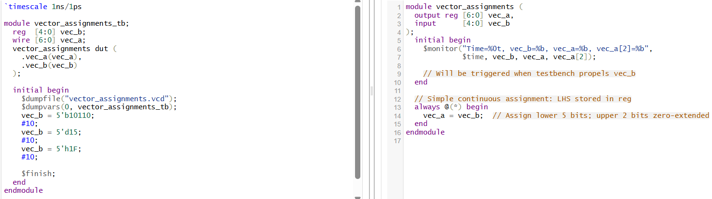

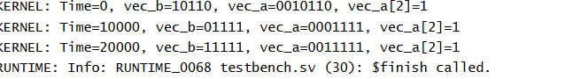

🎯 1. Vector Width Coercion: Automatic Padding
When you assign a smaller vector (vec_b, 5 bits) to a larger vector (vec_a, 7 bits), Verilog handles it automatically:
- It zero-extends vec_b to match the width of vec_a.
- That means the two most significant bits (MSBs) of vec_a become 0, while the lower bits copy from vec_b
⏬ 2. Bit Slicing: Accessing Individual Bits
Your $monitor prints vec_a[2], which is the third bit from the right. This demonstrates part-select:
🔁 3. Continuous Behavior: Always @(*) Block
Though your example uses initial blocks for simplicity, a typical combinational design uses:
This ensures vec_a updates immediately whenever vec_b changes, modeling real-time combinational logic
📝 4. System Task $monitor
- $monitor is used to continuously track signals and automatically print whenever their values change (after all updates settle)
- It's called once to set up the tracking, and then the simulator handles subsequent prints for you.

🔍 Summary: What Happens in Your Code
- vec_b updates (e.g., to 5'b10110).
- vec_a auto-fills with zero-extended bits (7'b0010110).
- Simulator detects change, and $monitor outputs time, full vector values, and the sliced bit.

Day 38: Vector Assignments (LESSER)
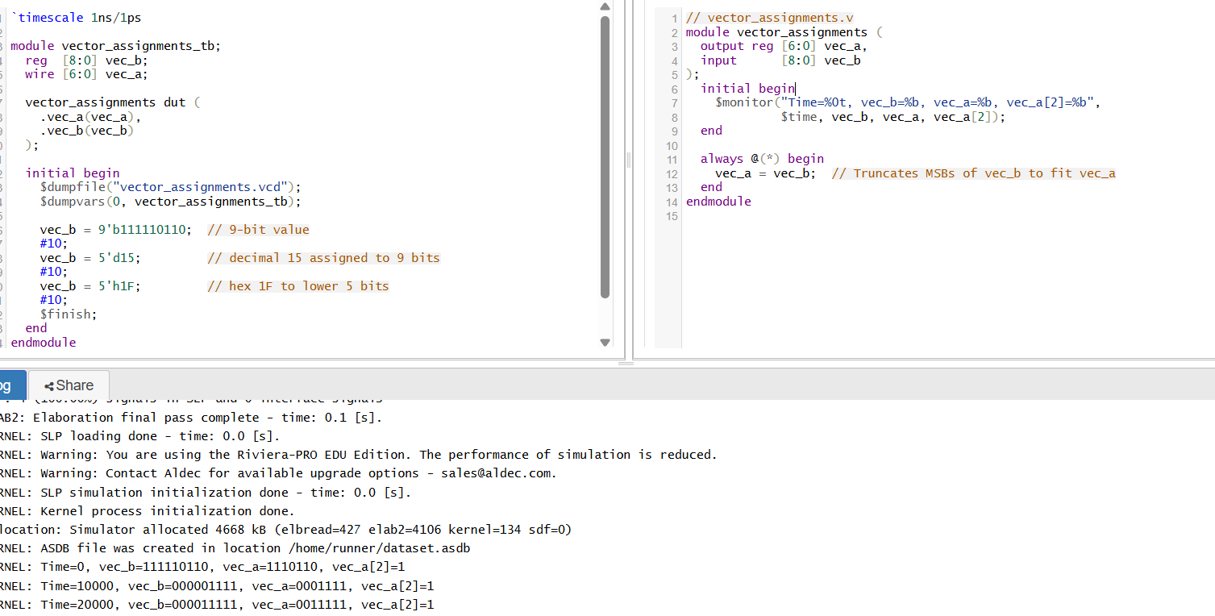

🔁 1. Truncation: Assigning Wider to Narrower
When you assign a wider vector (e.g., [8:0] vec_b) to a narrower vector (e.g., [6:0] vec_a), Verilog performs implicit truncation:
- Only the least significant bits (LSBs) fitting the target width are retained.
- Higher-order bits are discarded silently (though some tools may issue a warning) Example:

🔍 2. Zero-Extension vs Truncation
- Assigning a smaller vector to a larger one results in zero-extension (MSBs are filled with 0)
- Assigning a larger vector to a smaller one results in truncation: the MSBs that don't fit are dropped .
Visual summary:
Scenario | Result
5-bit → 7-bit (a = b;) | Zero-extend
9-bit → 7-bit (a = b;) | Truncate MSBs

✂️ 3. Part-Select: Accessing Specific Bits
Your $monitor prints vec_a[2], the third bit from the LSB, illustrating bit slicing or part-select:
- Useful for checking specific bit-level behavior after assignment
⚙️ 4. Using always @(*) for Combinational Logic
Even though your code may live in an initial block for testing, combinational logic is best modeled in:
verilog
CopyEdit
always @(*) begin
vec_a = vec_b;
end
This ensures vec_a is updated immediately whenever vec_b changes, simulating hardware’s parallel behavior
📋 5. Why It Matters
- ✅ Predictable resizing of data: smaller-to-larger zero extends; larger-to-smaller truncates.
- ⚠️ Silent truncation can cause unintended data loss—good practice is to use explicit slices or concatenations for clarity.
- 🛠 Combinational patterns (always @(*)) help implement real-time logic in hardware.

Day 39: Vector Assignments (EQUAL)
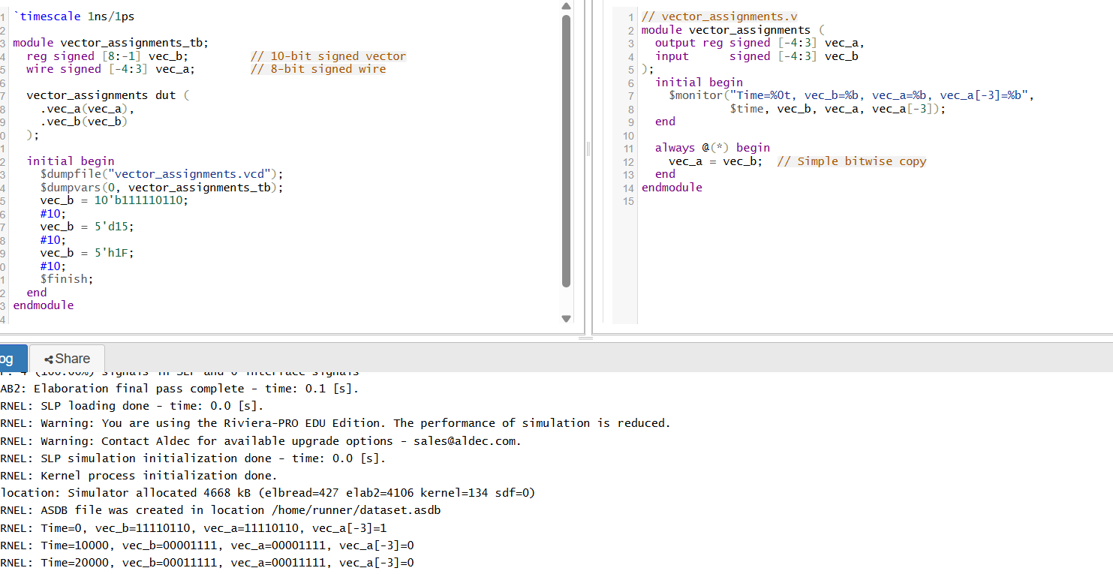

🧠 Theory Explanation
1. Vectors with Negative Indices
Verilog allows declaration of vectors with negative and reversed indices (e.g., [-4:3]). This syntax defines an 8-bit vector containing bits -4, -3, ..., 3. The order doesn’t impact synthesis—it simply defines 8 contiguous bit positions
2. Identical Ranges, Direct Mapping
Because both vec_a and vec_b use the same indexed range:
verilog
CopyEdit
reg signed [-4:3] vec_a;
reg signed [-4:3] vec_b;
When assigning vec_a = vec_b;, every bit from index -4 to 3 is copied directly—no truncation or shifting occurs.
3. Signed vs. Unsigned
The signed keyword tells the simulator to treat arithmetic operations and comparisons with two’s complement semantics. Though this example only performs bitwise assignment, signedness clarifies interpretation when using negative numeric constants .
4. Monitoring a Negative-Indexed Bit
Accessing vec_a[-3] is valid and prints the state of that specific bit. Negative indices are simply part of the defined vector indices, not an error .
5. Combinational Logic with always @(*)
Using always @(*) ensures vec_a updates immediately in response to changes in vec_b, modeling a combinational relationship.

Day 40: Vector Assignments (SIGNED)

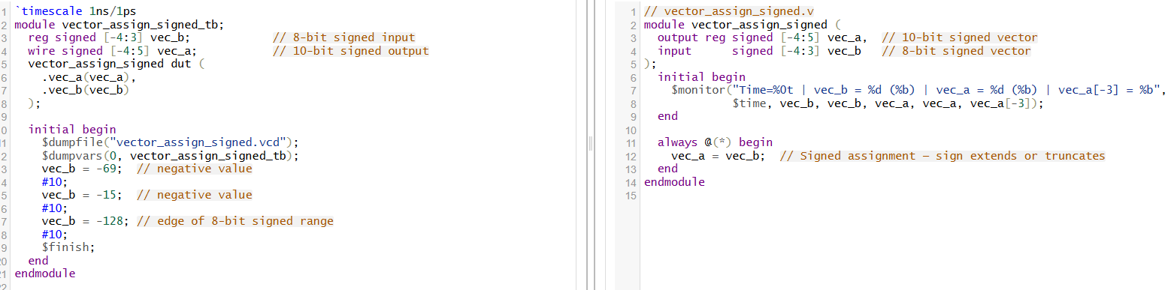

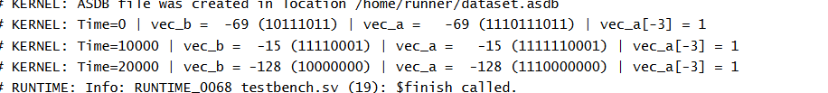
🧠 Theory & Explanation
1. Signed Vectors and 2’s Complement Representation
- Declaring signed tells Verilog to interpret MSB as the sign bit (two’s complement).
- For instance, vec_b = -69 in 8-bit means binary 101111011 (actually 8 bits: 10111011). The storage is two’s complement of 69.
2. Vector Width Mismatch: Sign-Extension
- vec_b is 8 bits ([-4:3]). vec_a is 10 bits ([-4:5]).
- Assigning vec_a = vec_b in signed mode sign-extends vec_b, filling MSBs with its sign bit (bit index 3) .
  - If vec_b[3] = 1, MSBs of vec_a are filled with 1.
  - If 0, filled with 0.
3. Example Walkthrough
Time | vec_b (decimal) | vec_b (8-bit binary) | vec_a (10-bit binary) | vec_a (decimal)
0 | −69 | 10111011 | 1110111011 | −69
10 | −15 | 11110001 | 111111110001 | −15
20 | −128 | 10000000 | 111000000000 | −128
4. Accessing vec_a[-3]
- Negative indices are valid in Verilog and select specific bits from your signed vector, useful for bitwise inspection .
5. Significance of Signedness
- Signed arithmetic requires all operands be declared signed for correct treatment
- Assigning signed to signed preserves sign in arithmetic and comparisons.
✅ Key Takeaways
- Declare signed to correctly interpret negative numbers.
- Width mismatch in signed context → sign-extension (not zero-extension).
- Negative bit indices ([-4:5]) define vector ranges but are syntactic—they create indexed bits, not negative positions
- Monitoring with %d and %b shows decimal and binary interpretation, highlighting how sign-extension preserves value.



